ARMVIEW STORM VOLLEYBALL CLUB
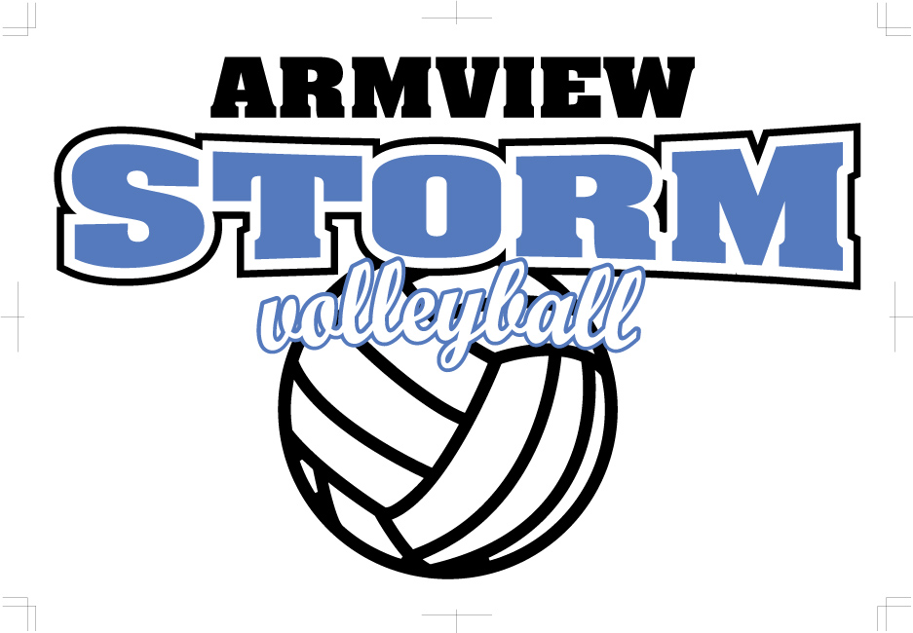
REGISTRATION FORM - 2020

Player Name

Address

Player Contact cell

Player Contact email __________________________________________________________

Date of Birth DAY _______ MONTH _____________ YEAR ________
Health Card # __________________________________________

Medical Conditions/Allergies to be aware of

Parent 1

Name: _____________________________________________________________________

Phone: _____________________________________________________________________

Email: ______________________________________________________________________

Parent 2:

Name: _____________________________________________________________________

Phone: _____________________________________________________________________

Email: ______________________________________________________________________

Emergency contact

Name: _____________________________________________________________________

Phone: _____________________________________________________________________

Email: ______________________________________________________________________

Tee shirt size _________________ Jogging pant size______________
Hoodie size __________________ Track jacket size ______________

GENERAL RELEASE
I release the Armview Storm Volleyball Club from any and all responsibility that may occur to the child named in this registration while participating with the volleyball team.

Parent Signature

PHOTO RELEASE
I give permission for the use of pictures and/or videos of my child for publicity and promotion of the team and/or club

Parent Signature

MEDICAL RELEASE
If your child requires medical attention and an Armview Volleyball Club official is unable to contact a parent, I give consent to have an Armview Volleyball Club Official take my child to the nearest medical facility.

Parent Signature

CLUB USE ONLY
TEAM FEE Cash/Cheque

